

FREEDOM SOS S-911 BL/HL User Manual Version 1.01.002

Chapter 1 – Operation Instructions

# Scopes

This document describes the S-911 Bracelet demo (V1.21) operation procedures. The corresponding hardware version is V3.0.

# Features

The main features include the SOS and Emergency call, phone book, SMS, instant Geo-fence, real time position reporting, and setting parameters remotely.

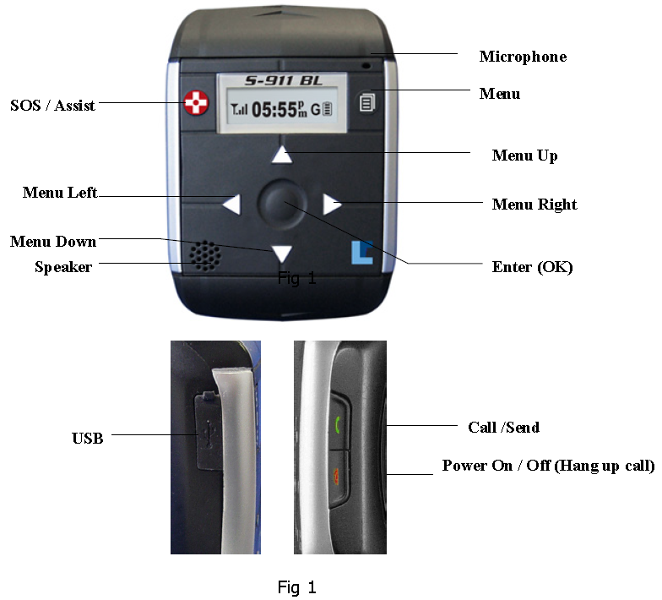

# Key Layout

There are 7 keys on front and 2 keys on the right side. See Fig 1 and Fig 2. Power on/off key is also used to hang up a phone call.

# Pre-Operation Instruction

Before operating the unit, verify that the unit has been charged with enough power.

# Charging

There are three main conditions for charging the unit listed below.

1. When the unit is off.
   1. Connect the USB cable to the charger. The LCD shows Fig 3. The flashing battery ICON means charging. Stable with full battery bar ICON means that the unit has finished charging. If you unplug the USB cable, the unit will shut down by itself.
2. When the unit is on.
   1. Connect the USB cable to charger. The batter ICON on main menu will flash.
3. Unit is on and is at full charging status.
   1. Connect the USB cable to charger. Press power on/off key and hold for 4 seconds. The Unit will change to full charging status like condition 1.

For conditions 1 & 3, the display shows “charging” and will switch to “Complete” with a full battery bar ICON, when the unit is fully charged.

For condition 2, when the battery finishes charging, the battery ICON will stop flashing.

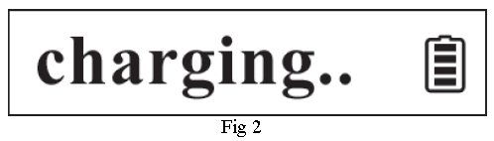

# Powering the Bracelet

To power the bracelet, press the power on/off key for 3 seconds. The LCD backlight will flash 3 times and initializing information will be shown on the display. See Fig 5. The initializing procedure will take approximately 3 seconds.



# Main Menu

After initializing, “**Main Menu**” is shown on LCD display, see Fig 6. The ICON to the left outlines the GSM status. The time is shown in the middle. The ICON on the far right is for battery status and the one nest to the battery icon is used to indicate the GPS status.

GSM ICON: The ICON on Fig 6 means GSM is fixed and provides how many bars it is connected with or otherwise shows it is trying to connect to GSM.

GPS ICON: Flashing “**G**” means GPS is trying to connect and a stable “**G**” means GPS has connected.



# Menu Operation

The menu key is the main button that allows the bracelet operator to access the available menu structure. The main menus that will be covered in this section are: Emergency Call, Phone Book, Short Message, Instant Geo-fence, Current Position, Speed and Heading and Configuration.

The Instructions to Navigate through these menus are listed below.

|  |  |  |
| --- | --- | --- |
| **Name** | **Description** | **Health Care Version Buttons** |
| Left Key | The menu title will scroll from the left side. |  |
| Right Key | A part of the menu title will be show and then scrolls across the display. |  |
| Up/Down | Navigates through menu or sub menu options. |  |
| Menu Key | Returns to the Main Menu |  |
| OK: | Confirms the current selection |  |

## Emergency call (see Fig s1)



The first sub menu “**Emergency Call**” will be shown on the LCD after pressing the menu key (see Fig s1). Only a part of the menu title is on the screen at first. After 2 seconds, the menu title will start to scroll until any function key is pressed and stop after 45 seconds of inactivity.

### Emergency call phone book

Press Left key: displays the name (see Fig s1.1.1)

Press Right key: displays the phone number (see Fig s1.1.2)

Press Up/Down: selects another phone book item.

Press Menu key: will return to the Main menu.

Press OK: Confirms the selection and calls the number.

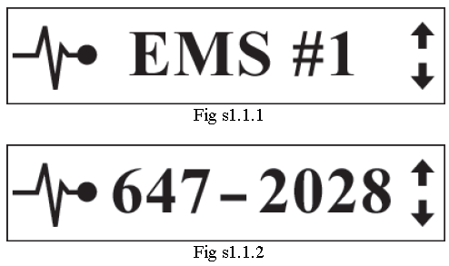

### Calling

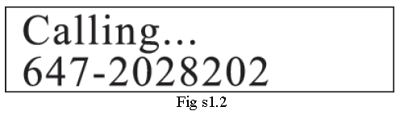

Press the Menu key or the Hang up key to cancel current call and return to the Main Menu. If call is successful, the display in figure 1.3 will appear.

### 1.3 Talking

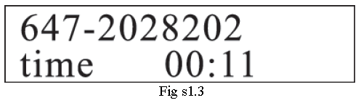

This display indicates that a 2-way voice session is open and counts the duration of the call.

By pressing the hang up key will hang up the current call and return to the Main Menu.

By pressing the menu key will return to the Main Menu screen while keeping the voice session open.

## Phone Book (see Fig s2)



### Phone Book Selection

Press Left key: Displays the name (see Fig s2.1.1).

Press Right key: Displays the phone number (see Fig s2.1.2).

Press Up/Down: Selects another phone book item.

Press Menu key: Will return to the Main Menu.

Press OK: Confirms the selection and calls the current number.

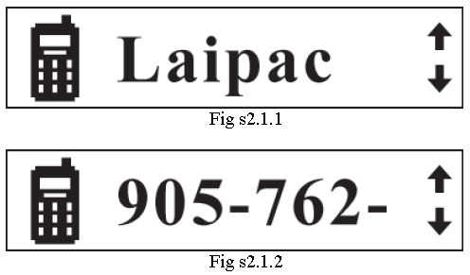

## Short Message (see Fig s3)

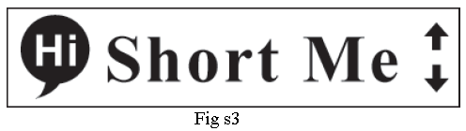

### Short Message Selection

Press Left key: Displays the name (see Fig s3.1.1).

Press Right key: Displays the short message (see Fig s3.1.2).

Press Up/Down: Selects another name or SMS item.

Press Menu key: Returns to the Main Menu.

Press OK: Confirms the selection and sends an SMS to the phone number belonging to this name.

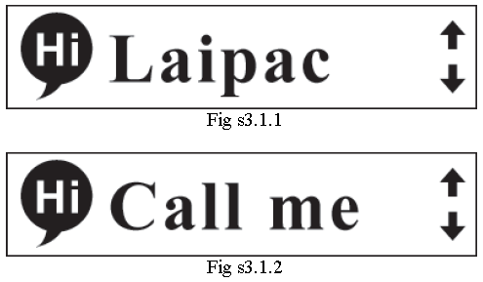

## Instant Geo-fence (see Fig s4)



### Geo-fence Setting

Press Left/Right: Selects different instant geo fence range.

Press Up/Down: Sets the current geo fence to available or unavailable.

Press Menu Key: Return to the Main Menu.

Press OK: Confirms the current selection and setting and then returns to the Main Menu.



## My Position (see Fig s5)



### Shows the Current Position (Latitude/Longitude)

Press the Menu key to return to the Main Menu.

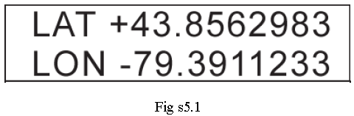

## Speed & Heading (see Fig s6)

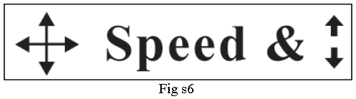

### 6.1 Shows the Current Heading and Speed (km/hr)

Press the Menu key to return to the Main Menu.

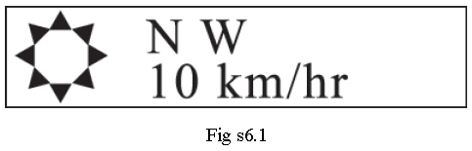

## Configuration (see Fig s7)

## 

### Configuration Selection Sub Menu (See Fig s7.1)

Press Left/Right: Sub menu or functions selection.

Press OK: Confirms and goes to the selected submenu.

Press Menu: Returns to Main Menu.

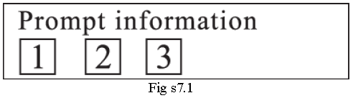

#### Set Date and Time

This is set automatically once the device interfaces with the mobile provider.

#### Set Time Zone

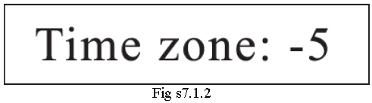

Press Up/Down: Changes the current value.

Press OK: Confirms the current menu operation setting and returns to the Main Menu.

Press Menu: Cancels the current menu operation setting and returns to the Main Menu.

#### Set Alarm

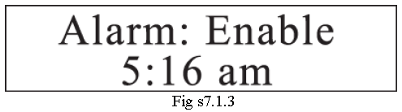

Press Up/Down: Changes the current value.

Press Left/Right: Selects the next operation item.

Press OK: Confirms the current menu operation setting and goes back to the Main Menu.

Press Menu: Cancels the current menu operation setting and returns to the Main Menu.

#### PGM. Download.

Press OK, and the Unit will reboot with the LCD screen showing “**Resetting…**”

# Call/Send Key Operations

If GSM is not fixed, press the call/send key and the unit will start to connect with GSM. To go to the phone book menu directly, press the call/send key. This can be accomplished when the bracelet is connected to GSM.

# SOS Key Operations

Press and hold the SOS key for 5 seconds, see Fig 5

1. Sends the SOS information to Monitoring Station server by GPRS.
2. Sends the SOS SMS to emergency phone 1.
3. Calls the SOS phone number.

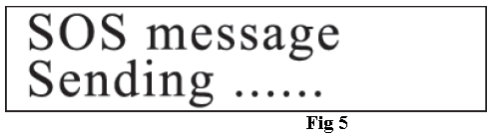

Press and hold the Power on/off key for 3-5 seconds and the unit will shut down.

Chapter 2 -- Health Care Differences

# Overview

## Quick Phone call on BL-HC (Health Care) version

This is a special feature for the Bracelet-HC version. It could be very helpful for users who use the one-touch phone call function.

Under the bracelet locaters cover menu, the user can execute this **Quick phone call operation** that comes with this Health Care bracelet model.

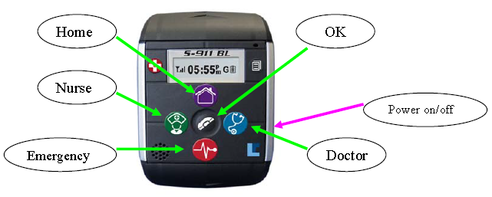

During the dialing process above, if the user wants to stop this operation, he can press “OK” to cancel current dialing operation and hang up.

If the call has been developed or completed, the user can press Power on/off side button to hang up the current call.

The BL V1.46 continues to provide the phone book function. Under BL’s cover menu user can press central “OK” button to enter into “Phone Book” sub menu. For operation of “Phone Book”, refer to the phone book section (Section 2) of Chapter 1 Operation Instruction of this manual.